Details of Camera Widgets

- To showcase Total No of Cameras configured, Online & Offline Cameras & The ratio of the online & offline cameras.
  - To showcase the ratio of the online & offline cameras, you can use progress bar as default option.
  - Also, provide 3 more options to it
- To showcase camera details based on Model Types. The model types are enlisted below:
- P Series, X Series, Q Series, T Series, L Series, Others
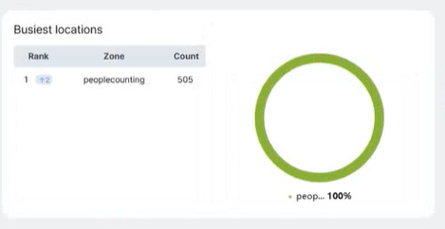
- Two columns will be there named are “Model Type”, “Count”
- You can provide more 2 options for the chart
- To showcase camera details based on Feature Types. The feature types are enlisted below:
- Motion Detection, People Detection, Vehicle Detection, Slip & Fall Detection, Traffic Detection, Crowd counting etc.


